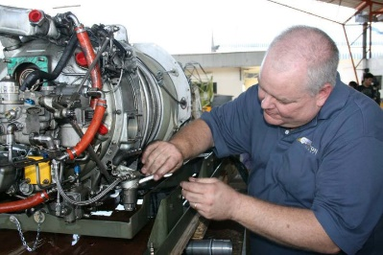
PT6…
Craymer’s Counsel

For those that don’t know me, my name is Robert Craymer and I work for Covington Aircraft. I have worked in and around PT6A’s for over 30 years. I still get to hear and learn new things and I always tell everyone that, “I may not know everything about engines, but I know people who can answer almost any question.” I’m excited to utilize this editorial to answer maintenance questions that I hear throughout the year, share maintenance tips, and distribute important PT6A updates that we receive.
This month’s topic we will be discussing borescope inspection. If any of you have attended any of the classes that have been given over the years, you know a borescopes inspection is a very popular topic. The borescope is a tool that allows an engine’s condition to be examined in between hot section inspections and/or overhauls.
While borescopes have become more widely available and the cost has become more affordable, if you decide to invest in one get a quality borescope that will allow you both to take pictures and movies. In addition, I suggest one with a replaceable memory card for additional storage capabilities. We have several models of borescope at Covington, but my personal favorite is the Olympus iPlex G Lite. This is not an endorsement of any borescope, just letting you know the one that I generally have enjoyed using. The other tool required when performing a borescope is an engine specific tube that can be procured through Pratt & Whitney Canada or Covington.
The borescope can be used to inspect the hot section, but it does not replace or diminish the importance of performing normal scheduled hot section inspections. It is intended only to monitor the condition of the internal components. A side benefit of a borescope is being able to recognize things that may need to be addressed prior to normal repair schedule. It also provides you with documentation when it comes to Pratt& Whitney Canada warranty claims.
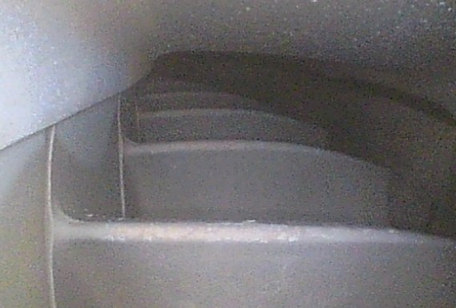

Borescope picture of compressor turbine blades.

A word of caution, DON’T PUT YOUR BORESCOPE IN A HOT ENGINE! It is possible to cause great borescope damage if the internal parts are still hot. Best practice is to make sure the engine is cool.
What are you looking for when performing a borescope? Basically, what I am looking for are abnormalities. If I see something on a blade or vane that looks different from the rest, I know that spot needs more evaluation. It is not just cracks that we are looking for, but carbon build up, buckling or burning, rubbing, erosion and for foreign object damage are also items on our list. Also, don’t forget to check your compressor for foreign object damage (FOD) as well.
What do we do if we find issues? Although your borescope operator may be highly skilled in interpreting what they see, I suggest that you reach out to people you know have experience and you trust. I receive many pictures from borescopes for analysis. Once I receive the pictures, I discuss my findings with several expert sources prior to offering an opinion. My experience is you can never have too many educated inputs.
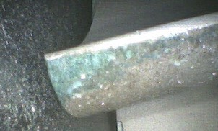

Compressor Turbine blade tip erosion

This brings us to when a borescope inspection should be performed. I have customers that have a borescope performed annually. Some do a borescope inspection in conjunction with a pre-purchase, which is always a good idea. Pratt & Whitney Canada requires a borescope inspection when you perform your fuel nozzle maintenance, which is normally every 200-400 hours! If you have a warranty issue arise, your FSR will ask for your periodic borescope results. If you don’t have borescope documentation, it could cause a delay or denial of warranty claims.
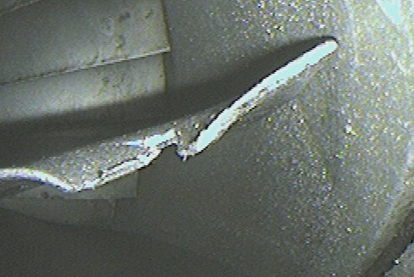
Compressor blade with foreign object damage.

Remember, a borescope is a wonderful tool. Take pictures/videos and keep everything for your records. Talk to people with experience about findings. This will allow you to utilize the borescope to help control operating costs by being aware of what is going on inside your engine. Finding issues early saves money and everyone likes that.
Please reach out to me at robertc@covingtonaircraft.com if you have any questions and I’ll be glad to assist.

