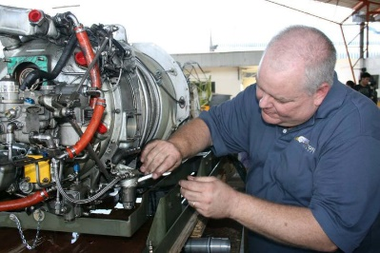
PT6…
Craymer’s Counsel
Holidays, hunting, family and fun! It is that time of year for North America Ag Aviation. For many the airplanes are scheduled for annual inspection or put to bed until next season. For some operators the season continues well into the upcoming months. For those who are done for the season, this article is for you.
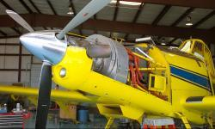
If you are in the deer stand or sharing a meal with family and friends, remember that your engine still needs some love. Just like you depend on your engine to take care of you, your engine relies on you to take care of it. During the times of the year that you don’t fly every day you need to make sure that your engine is preserved and stored properly. Unfortunately, I have witnessed firsthand what can happen if you don’t follow some simple steps to keep your engine protected when not in use.

Like any machine, the times the PT6 engine is not used can be just as hard or harder on it than the times when it is being used routinely. Pratt and Whitney Canada has given us some very easy to follow guidelines that will make sure when you are ready to work, so is your engine. Everything regarding preservation is scheduled around time frame and has significant consequences. If an engine is not preserved per the published schedule the engine could suffer corrosion damage and warranty could be voided. The only way to check for corrosion damage is to disassemble the engine for visual inspection of ALL components. Therefore, we always provide time to discuss the importance of engine preservation.
Here is what you need to know:
If the engine is going to be inactive for 0 to 7 days, all that is required is to make sure that the engine is sheltered. Humidity changes and temperature changes that can cause condensation are grounds to move your preservation plan to the next level. Also, if there is a lot of salt in the atmosphere you live in you want to do a clean water rinse (desalinization wash) prior to storing the airplane. Exhaust covers, inlet covers and securing the prop are really the only other requirements.
The second calendar interval classification is 8 to 28 days. This area of the calendar is the most common in ag aviation. First step is to run the engine and follow the 0 to 7 day instructions. Next you will need to add desiccant bags and a humidity indicator in the exhaust duct. The objective is to maintain and confirm humidity level at 40%. Check the humidity indicator every couple of weeks, if it turns pink, replace the desiccant and indicator. Make sure there is not a source of humidity near the engine, and if there is make sure to remove it.
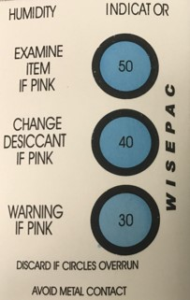
If your off time dictates that your engine must sit 29 to 90 days there are a couple additional steps to take. Washing the engine inside and out, touching up any of the protective coatings that are missing and lubricating the linkage. Next, disconnect the fuel supply line and cap at the oil-to-fuel heater. Disconnect the fuel line at the flow divider inlet and then add the proper preservation oil. Instructions in the maintenance manual show you how to do a motoring run to replace the fuel in the system with the preservation oil. Then of course you cap and cover everything. Make sure that you also follow the 0 to 28 days steps and don’t forget your humidity indicator.

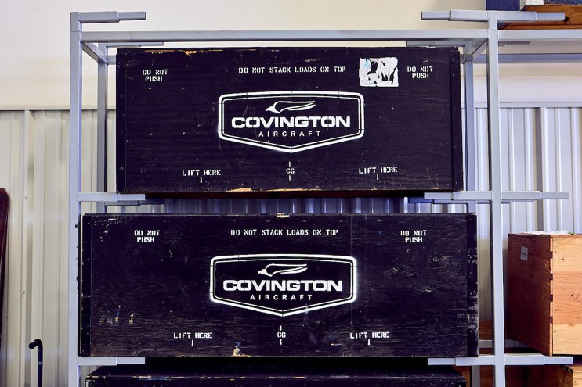
For some the engine may sit over 90 days. For those, you must do all the above plus drain the oil, remove the oil filter and coat the flanges and other exposed surfaces with either oil or a preservation compound as described in the engine maintenance manual. Add a tag to your oil filler cap advising that the oil has been drained and include the date of preservation. If you expect the engine to sit longer than a year, you must remove the engine, do all the above and store it in a proper shipping container.

What happens if I don’t?
If your engine is not preserved 8-28 days, prior to engine start, you must do a Total Acid Number test to the engine oil. Up to 90 days there are numerous other things you must check and do as well as a specific start and run procedures. If your engine goes up to a year unpreserved; fuel nozzles, accessory bench checks and additional inspections are required. In addition, the engine must be disassembled and inspected for corrosion.
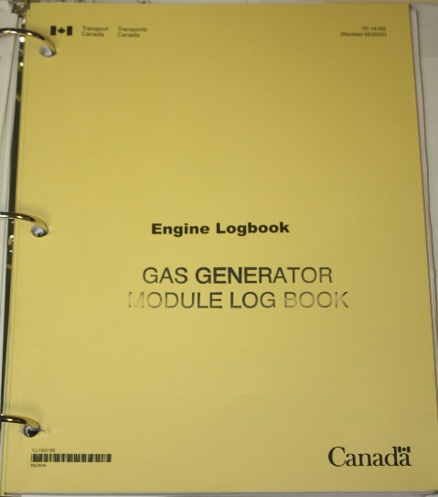
The easy alternative is to run the engine weekly. That may seem like a nuisance, but maybe not when you compare it to the cost of parts replacement or down time for inspections. When you perform these runs you want to run at 80% power for 10 minutes. This reduces the condensation in the oil system and prevents fuel stagnation.

Remember that if you don’t record the work you do to preserve your engine in the engine logbook then it didn’t happen. Engine preservation must be documented. All of this is especially important if you have Pratt & Whitney Canada warranty on your engine. You don’t want to put your warranty claim in jeopardy just because the engine wasn’t preserved or stored properly.
I hope everyone is excited as we move through the convention season. I have already attended a couple of state shows. It was great to get out and interact with people again. Looking forward to the upcoming shows and the classes that I get to teach plus the time to visit with colleagues and friends in the industry.
Please reach out to me at robertc@covingtonaircraft.com if you have any questions and I’ll be glad to assist.

